**JOBSHEET 5**

**SELECTION**

1. **Objective**
2. Students are able to solve problems/case studies using simple selection syntax and nested selection.
3. Students are able to apply simple selection syntax and nested selection into Java programs.
4. **Practicum**

**2.1 Experiment 1 : Implementing IF and IF-ELSE to Print KRS**

**Trial Time: 40 minutes**

At the beginning of each semester, students are required to print their KRS (Kartu Rencana Semester or Student Study Plan) and signed by their Academic Advisor. The SIAKAD system will check the student's UKT (or tuition fee) payment status. If the student has paid the UKT, the system displays the KRS for printing. Based on this scenario, a Java program will be created with the following steps.

1. Open your local repository **PraktikumDaspro** cloned previously via Visual Studio Code, then create a **jobsheet5 folder** by typing **mkdir jobsheet5** in the terminal .

The jobsheet5 folder will appear in the Visual Studio Code Explorer.

1. Create a new file with the name **ifCetakKRSNoPresensi.java** in **the jobsheet5 folder** that has been created
2. Create a basic Java program structure with the **main() function.**
3. Import library Scanner and declare scanner with name **sc**



1. Add the following code to receive input from the keyboard which is then stored in the boolean variable **uktLunas**

1. Create an IF selection structure to check whether UKT has been paid in full.

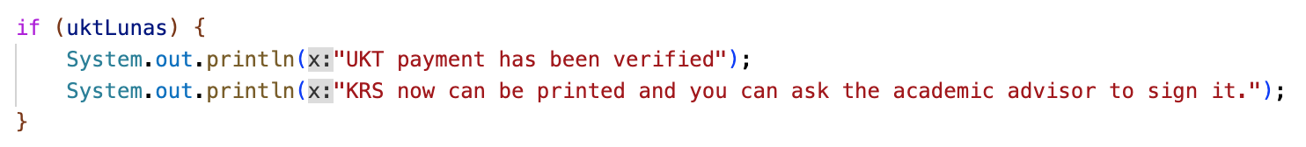

1. Compile and run the program to produce the following display.

1. Commit your program to Github with the message “Attempt 1”

**Question**

1. Why doesn't the check in the IF structure involve conditions with relational operators?
2. When the program is run, then you enter the value **false** , what is the result?
3. The system needs to provide information that if the user enters a false value , the output will be "Registration rejected. Please pay UKT first." Modify the program by adding an ELSE!
4. **Commit and push your modifications to Github with the message “Test Modification 1”**

**2.2. Experiment 2: SWITCH-CASE for Printing KRS**

**Trial Time: 60 minutes**

At the beginning of each semester, students are required to print their KRS (Student Study Plan) for signature by their Academic Advisor. The SIAKAD system will check the student's current semester and then display that semester's KRS for printing. Based on this case, the Java program is created with the following steps.

1. Create a new file named **switchCetakKRSNoPresensi.java** in **the jobsheet5 folder**
2. Create a basic Java program structure with the **main() function.**
3. Import library Scanner and declare scanner with name **sc**
4. Add the following code to receive input from the keyboard which is then stored in the **semester** variableof type int.

1. Create a SWITCH-CASE selection structure to check the current semester.

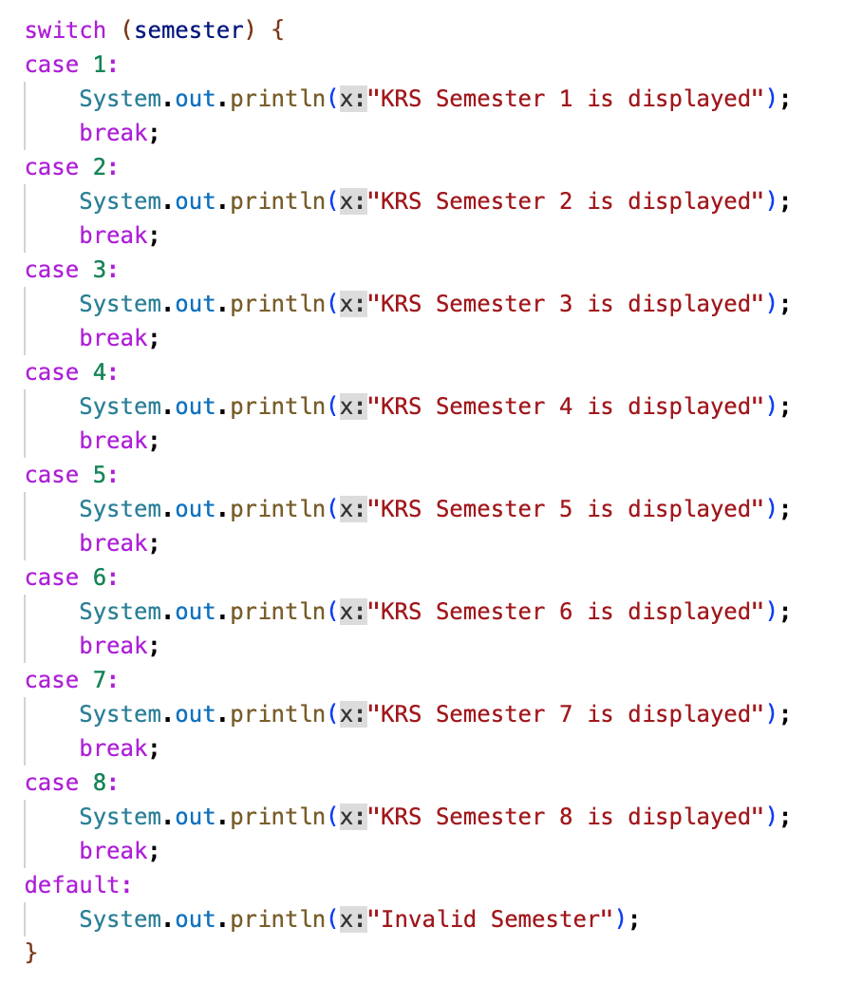

1. Compile and run the program to produce the following display.

1. Commit your program to Github with the message “Attempt 2”

**Question**

1. What is the function of syntax **break** ?
2. What is the role of syntax **default** on SWITCH-CASE selection structure?
3. Create a new file named **ifElseCetakKRSNoPresensi .java** . This file contains the program resulting from the transformation of the KRS printing program using the SWITCH-CASE structure that has been created into the IF-ELSE IF-ELSE form .
4. **Commit and push your modifications to Github with the message “Trial Modification 2”**

**2.3. Experiment 3: Nested IF to Check Thesis Examination Requirements**

**Trial Time: 90 minutes**

A student will register for a thesis exam. The SIMTA system will first check the administrative requirements, that the student must be free of compensation. If this requirement is met, the system then checks the guidance log records. To be able to register for the exam, students must have at least 8 guidance sessions with supervisor 1 and at least 4 guidance sessions with supervisor 2. If all requirements are met, the student can proceed to the thesis exam registration process. If not, the system will display the reason for failure. Based on this case, a Java program is created with the following steps.

1. Create a new file named **nestedUjianSkripsiNoPresensi.java** in **the jobsheet5 folder**
2. Create a basic Java program structure with the **main() function.**
3. Import library Scanner and declare scanner with name **sc**
4. Declare a message variable of type String to store the output result of the condition.A close-up of a logo

   Description automatically generated
5. Add the following code to receive input from the keyboard regarding component information, which is then stored in the **compensationStatus** variable with data type String.



*Note: trim() function is used to remove spaces before and after a String.*

1. Add the following code to receive input from the keyboard regarding guidance log information which is then stored in the variables **supervisor1** and **supervisor2** of type inRed text on a white background

   Description automatically generated
2. Nested -IF selection structure to check the condition of the component at the first level and the number of guidance logs at the second level.A screenshot of a computer program

   Description automatically generated
3. Compile and run the program to produce the following display.

1. Commit your program to Github with the message “Attempt 3”

**Question**

1. What happens if a student answers " No " to **compensationStatus** question? Why is that?
2. Explain the meaning of the following code snippet!

if (supervisor1 >= 8 && supervisor2 >= 4) {

1. What is the student eligibility process from start to finish? Explain it in detail for all conditions.
2. **Task**

**Assignment Completion Time: 120 minutes**

1. Reopen the file **ifCetakKRSNoPresensi.java** , add a new line in the main function to transform the modified KRS printing program using the IF-ELSE structure that has been created into the Ternary Operator form! **Commit and push your program to Github with the message “Task 1”**
2. Pay attention to the following flowchart .

Implement the flowchart into Java code using an IF-ELSE selection structure! **Commit and push your program to GitHub with the message "Task 2"**

1. Implement the flowchart you created for the Exercise 5 of the Basic Programming Course regarding the library system and campus WIFI access into program code! **Commit and push your program to GitHub with the message "Assignment 3."**